Lab 7
Natnael Kebede
Section 1
- Screen capture showing the fingerprint generated by the key creation process of Kleopatra
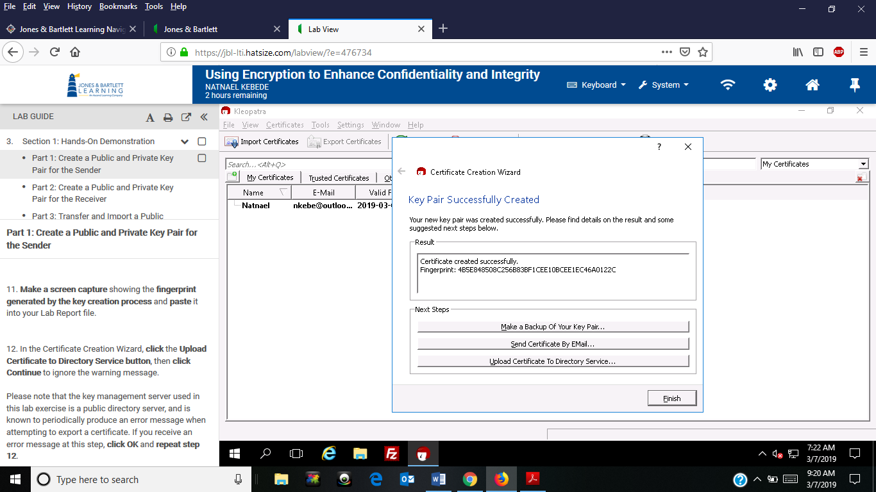
- Screen capture showing my email address in the Certificate Server Certificate lookup
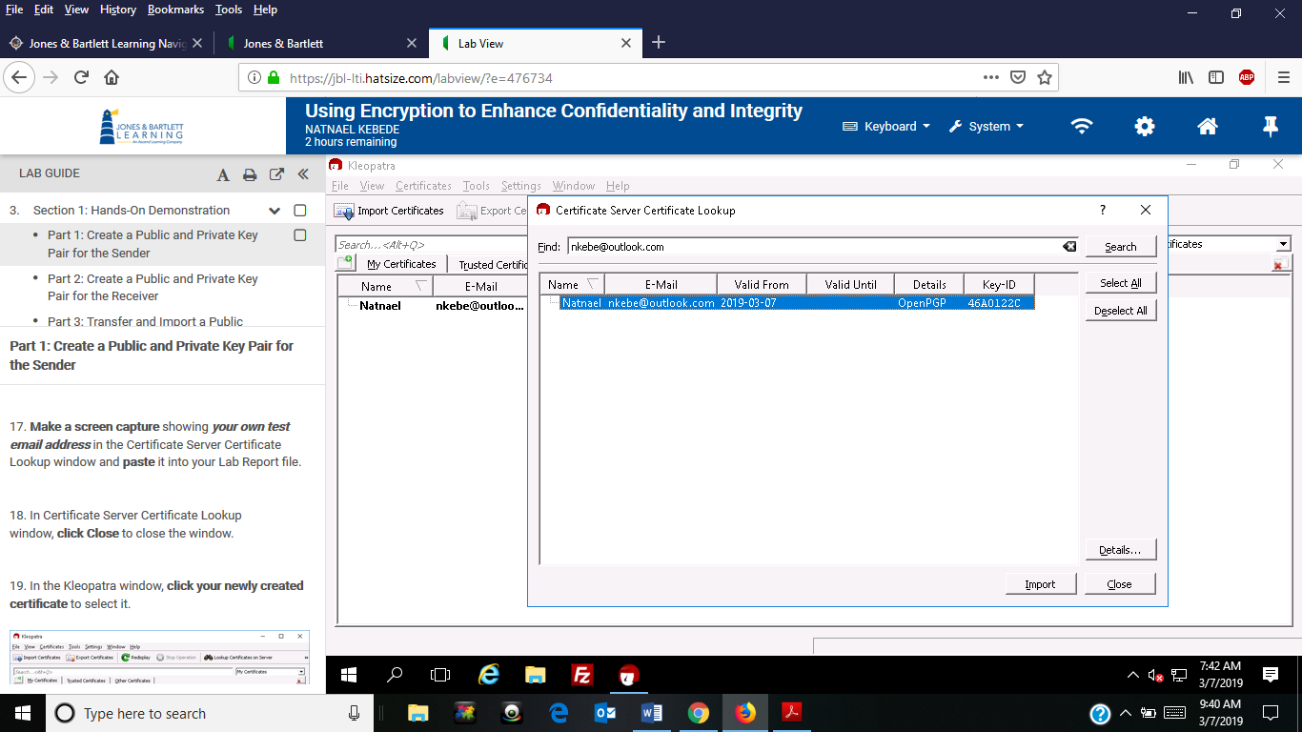
- Screen capture showing the Kleopatra decryption results window and the secret-message.txt file in Notepad
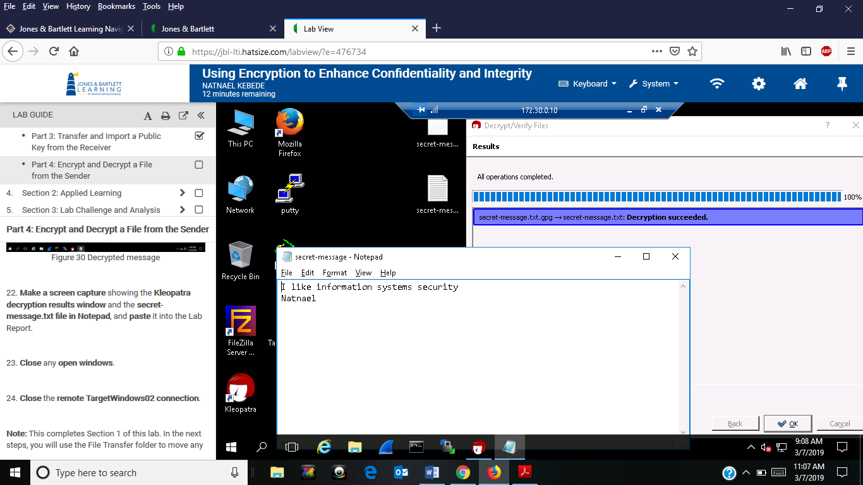
Section 2
- Screen capture showing the fingerprint generated by the key creation process of Kleopatra
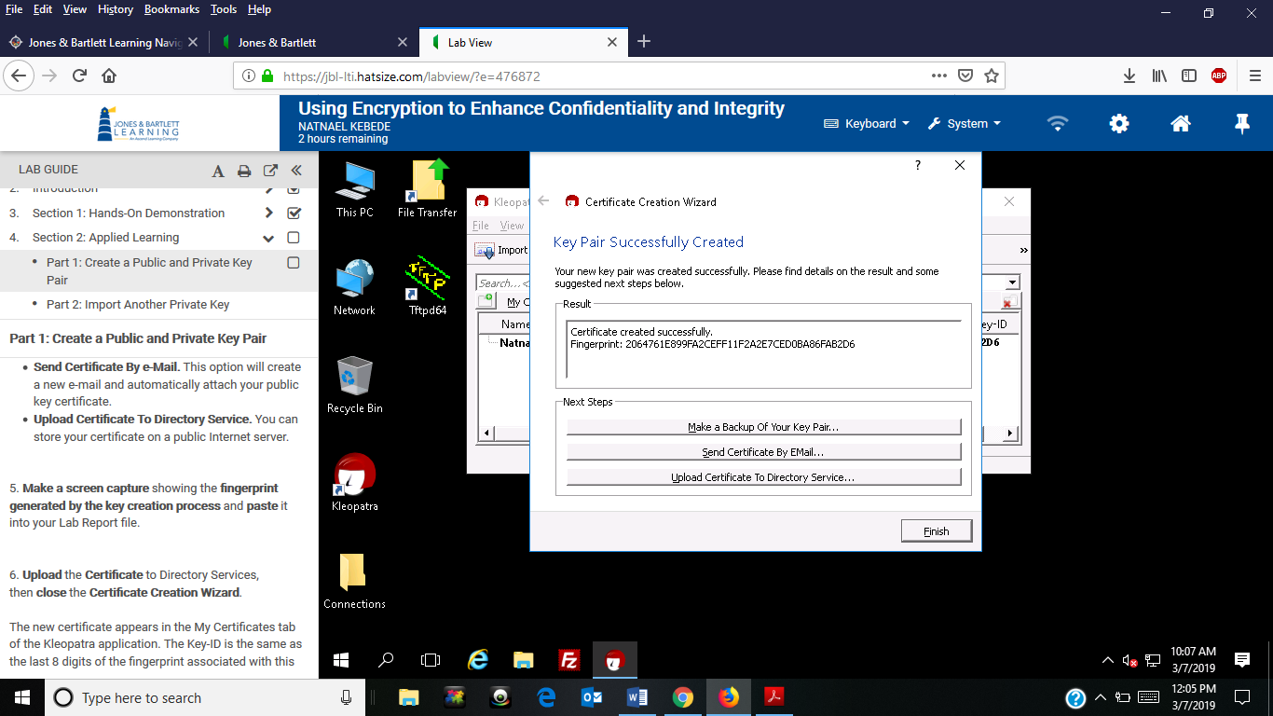
- Screen capture showing my email address in the Certificate Server Certificate lookup
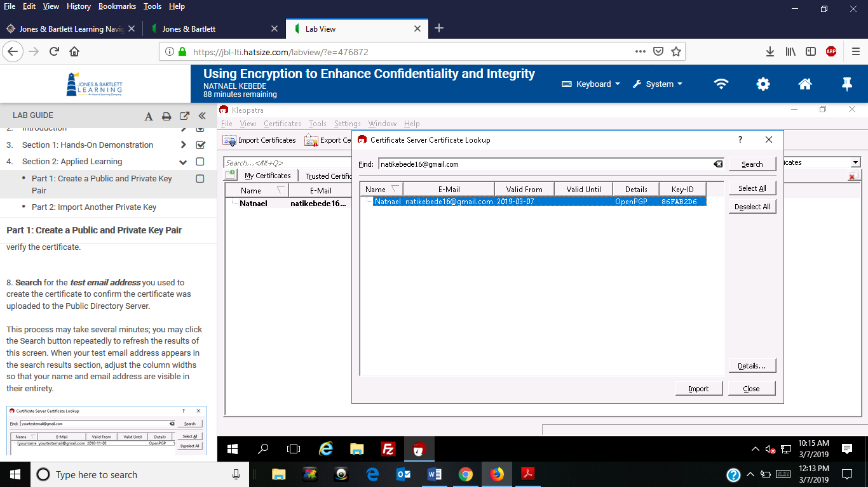
- Screen capture showing the certificate details for the student certificate
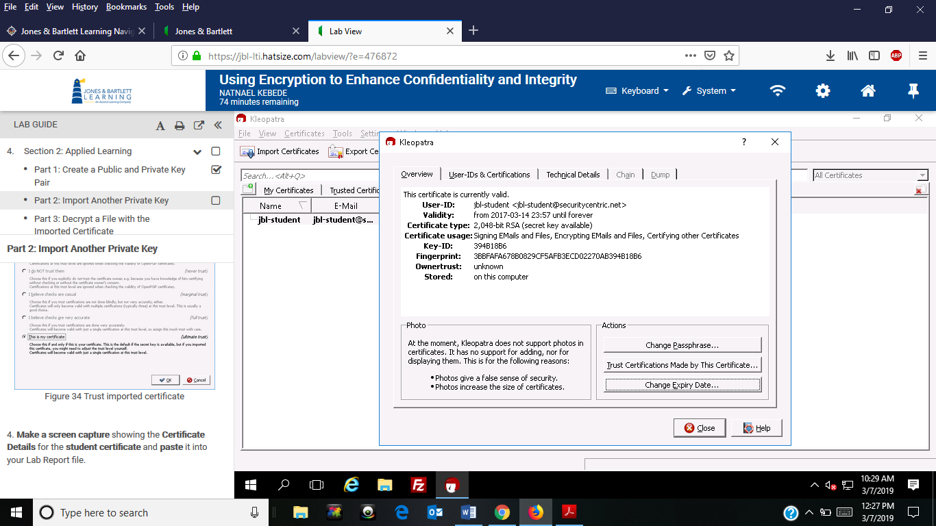

- Screen capture showing the Kleopatra decryption results window and the Secure_note.txt
